Practical DBMS
Name : Kimsan
Roll No: 2338138
Submitted to: Dr. Geethanjali Kher
Course: Bsc (P) Physical Science with Computer Science
I. Create and use the following student-society database schema for a college to
answer the given (sample) queries using the standalone SQL editor.

# create tables
- Create Student Table
create table student(
rollno char(6),
studentname varchar(20),
course varchar(10),
dob date,

primary key(rollno)
);

- Create Society Table
create table society(
socid char(6),
socname varchar(20),
mentorname varchar(15),
totalseat integer,

primary key(socid)
);

- Create Enrollment Table
create table enrollment(
rollno char(6),
sid char(6),
date_of_enrollment date,

primary key (rollno),
foreign key (rollno) REFERENCES student(rollno),
foreign key (sid) REFERENCES society(socid)
);

# insert some data
- Insert into Student Table
INSERT INTO student (rollno, studentname, course, dob) VALUES
('S001','Asha Verma','BSc CS','2003-05-14'),
('S002','Ravi Kumar','BCom','2002-11-23'),
('S003','Meena Patel','BA Eng','2003-07-02'),
('S004','Rahul Singh','BSc CS','2002-03-10'),
('S005','Pooja Sharma','BBA','2003-12-29'),
('S006','Anil Yadav','BSc Phy','2002-06-09'),
('S007','Kiran Das','BSc CS','2003-09-17'),
('S008','Neha Gupta','BCom','2002-04-19'),
('S009','Suresh Rai','BA Hist','2001-12-05'),
('S010','Divya Jain','BSc Math','2003-01-22'),
('S011','Amit Roy','BSc Phy','2003-07-13'),
('S012','Sneha Tiwari','BBA','2003-03-09'),
('S013','Rohit Mehra','BA Eng','2002-09-21'),
('S014','Manish Bansal','BSc CS','2003-11-03'),
('S015','Priya Saini','BCom','2002-05-27'),
('S016','Kavita Nair','BSc Phy','2003-10-15'),
('S017','Harshit Malhotra','BSc Math','2003-02-12'),
('S018','Tanya Sharma','BA Hist','2001-10-06'),
('S019','Gaurav Joshi','BBA','2003-08-18'),
('S020','Sakshi Verma','BSc CS','2002-09-25'),
('S021','Mohit Rana','BSc Phy','2003-04-07'),
('S022','Ananya Singh','BA Eng','2002-01-03'),
('S023','Deepak Chauhan','BCom','2003-07-29'),
('S024','Nisha Gupta','BSc Math','2002-06-11'),
('S025','Abhishek Das','BSc CS','2003-11-26'),
('S026','Kritika Bhat','BSc Phy','2003-12-02'),
('S027','Kunal Jain','BBA','2003-10-19'),
('S028','Shruti Patel','BA Hist','2002-08-30'),
('S029','Vikas Mishra','BSc Math','2003-02-09'),
('S030','Riya Kapoor','BSc CS','2003-03-24');
- Insert into Society Table
INSERT INTO society (socid, socname, mentorname, totalseat) VALUES
('SO001','Music Club','Mr. Rao',25),
('SO002','Dance Club','Ms. Neha',20),
('SO003','Drama Society','Mr. Amit',15),
('SO004','Art Circle','Mrs. Joshi',18),
('SO005','Science Forum','Dr. Nair',30),
('SO006','Photography','Mr. Anand',20),
('SO007','Robotics Club','Dr. Mehta',25),
('SO008','Literary Club','Ms. Rekha',20),
('SO009','Coding Hub','Mr. Arjun',30),
('SO010','Eco Society','Dr. Sharma',18),
('SO011','Sports Club','Mr. Raj',40),
('SO012','Yoga Club','Ms. Divya',25),
('SO013','Astronomy','Dr. Kiran',20),
('SO014','Finance Club','Mr. Ravi',25),
('SO015','Film Society','Ms. Priya',15),
('SO016','Social Work','Mr. Suresh',20),
('SO017','AI Club','Dr. Tiwari',25),
('SO018','Math Circle','Dr. Rao',30),
('SO019','Gaming Club','Mr. Nikhil',20),
('SO020','CyberSec Club','Mr. Adarsh',25),
('SO021','Electronics','Dr. Kapil',30),
('SO022','Quiz Club','Ms. Jaya',15),
('SO023','Nature Club','Mr. Ghosh',20),
('SO024','Entrepreneurship','Mr. Manoj',25),
('SO025','Public Speaking','Ms. Anu',20),
('SO026','Film Makers','Mr. Rohan',15),
('SO027','Design Club','Ms. Tanvi',18),
('SO028','Poetry Society','Mr. Vivek',20),
('SO029','Data Science','Dr. Lal',25),
('SO030','Chess Club','Mr. Deep',15);
- Insert into Enrollment Table
INSERT INTO enrollment (rollno, sid, date_of_enrollment) VALUES
('S001','SO001','2023-08-01'),
('S002','SO009','2023-08-02'),
('S003','SO004','2023-08-03'),
('S004','SO007','2023-08-03'),
('S005','SO002','2023-08-04'),
('S006','SO005','2023-08-04'),
('S007','SO009','2023-08-05'),
('S008','SO011','2023-08-06'),
('S009','SO015','2023-08-07'),
('S010','SO018','2023-08-07'),
('S011','SO017','2023-08-08'),
('S012','SO006','2023-08-09'),
('S013','SO014','2023-08-09'),
('S014','SO009','2023-08-10'),
('S015','SO010','2023-08-10'),
('S016','SO021','2023-08-11'),
('S017','SO018','2023-08-12'),
('S018','SO023','2023-08-13'),
('S019','SO025','2023-08-14'),
('S020','SO017','2023-08-14'),
('S021','SO029','2023-08-15'),
('S022','SO008','2023-08-16'),
('S023','SO020','2023-08-16'),
('S024','SO018','2023-08-17'),
('S025','SO027','2023-08-17'),
('S026','SO030','2023-08-18'),
('S027','SO003','2023-08-18'),
('S028','SO028','2023-08-19'),
('S029','SO026','2023-08-19'),
('S030','SO001','2023-08-20');
Question1: Retrieve names of students enrolled in any society.
select distinct s.studentname from student s join enrollment e on s.rollno = e.rollno;

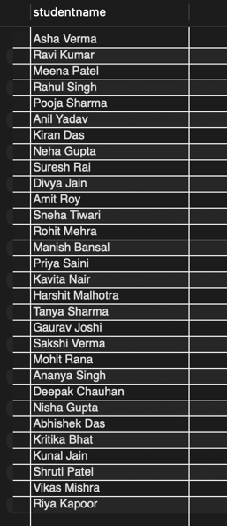
Question2: Retrieve all society names.
select socname from society;

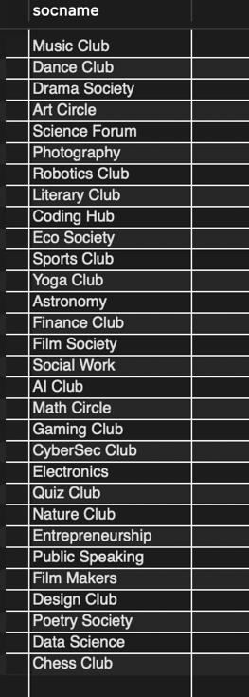

Question3: Retrieve students' names starting with the letter ‘A’.
select studentname from student where studentname like 'a%';

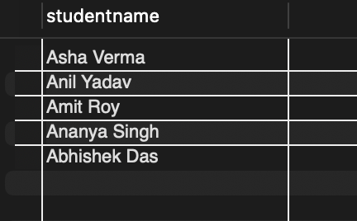
Question4: Retrieve students' details studying in courses ‘computer science’ or ‘chemistry’.
select * from student where course in ('computer science', 'chemistry');

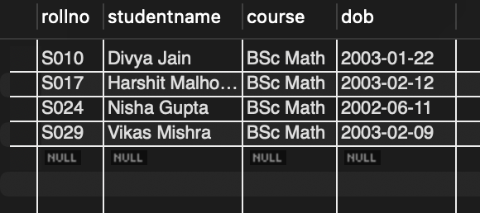

Question5: Retrieve students’ names whose roll number starts with ‘X’ or ‘Z’ and ends with ‘9’.
select studentname from student where (rollno like 'x%9' or rollno like 'z%9');

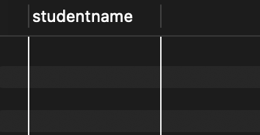

Question6: Find society details with more than N total seats (input by user).
set @n = 20; -- user input
select * from society WHERE totalseat > @n;

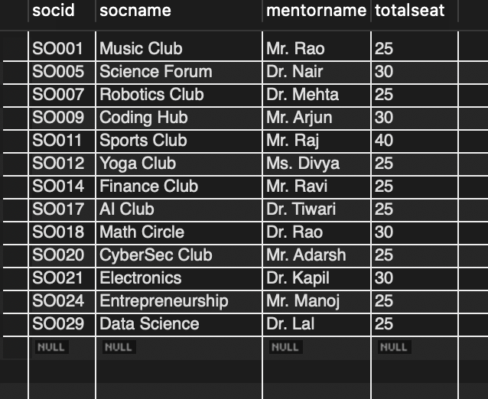

Question7: Update mentor name for a specific society.
update society
set mentorname = 'new mentor' where socid = ' SO001';
select distinct mentorname from society order by socid;

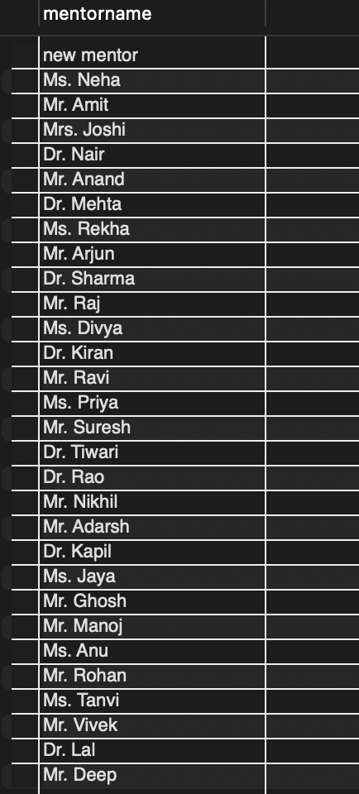

Question8: Find society names in which more than five students have enrolled.
select s.socname from society s join enrollment e on s.socid = e.sid group by s.socid having count(e.rollno) > 5;

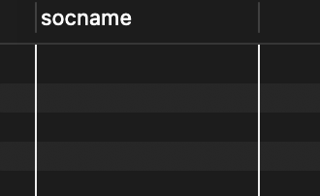

Question9: Find youngest student enrolled in society ‘NSS’.
select s.studentname, s.dob from student s join enrollment e on s.rollno = e.rollno join society so on e.sid = so.socid where so.socname = 'nss' order by s.dob desc limit 1;

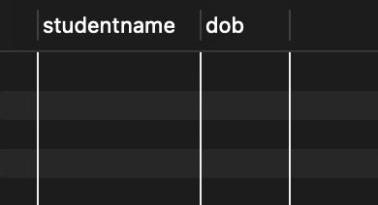

Question10: Find the most popular society (maximum enrollments).
select s.socname, count(e.rollno) as total from society s join enrollment e on s.socid = e.sid group by s.socid order by total desc limit 1;

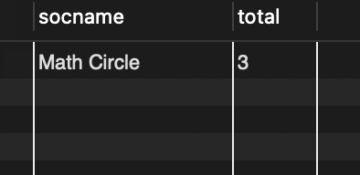

Question11: Least popular society (minimum enrollments).
select s.socname, count(e.rollno) as total from society s join enrollment e on s.socid = e.sid group by s.socid
order by total asc limit 1;

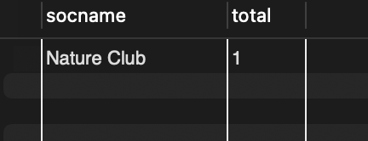

Question12: Students not enrolled in any society.
select studentname from student where rollno not in (select rollno from enrollment);

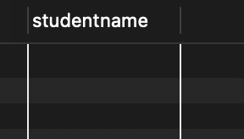

Question13: Students enrolled in at least two societies.
select s.studentname from student s join enrollment e on s.rollno = e.rollno
group by s.rollno
having count(e.sid) >= 2;

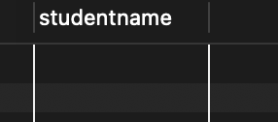
Question14: Societies with maximum students enrolled.
select s.socname, count(e.rollno) as total from society s join enrollment e on s.socid = e.sid group by s.socid
having total = (
select max(cnt)
from (
select count(e2.rollno) as cnt
from enrollment e2
group by e2.sid
) as t
);

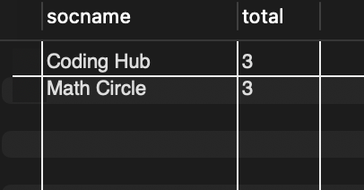

Question15: Students enrolled in any society and their society names.
select st.studentname, so.socname from student st
join enrollment e on st.rollno = e.rollno
join society so on e.sid = so.socid;

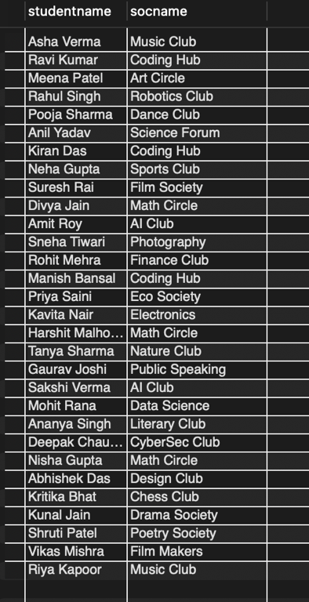

Question16: Students enrolled in any of the three societies ‘Debating’, ‘Dancing’, or ‘Sashakt’.
select distinct st.studentname from student st
join enrollment e on st.rollno = e.rollno
join society so on e.sid = so.socid
where so.socname in ('debating', 'dancing', 'sashakt');

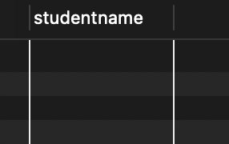

Question17: Societies whose mentor has ‘Gupta’ in the name.
select * from society where mentorname like '%gupta%';

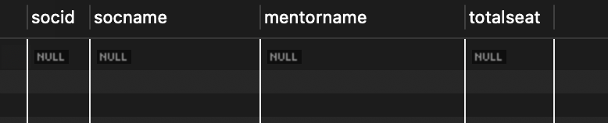

Question18: Societies where enrolled students are only 10% of total capacity.
select s.socname from society s left join enrollment e on s.socid = e.sid group by s.socid, s.socname, s.totalseat
having count(e.rollno) = 0.1 * s.totalseat;

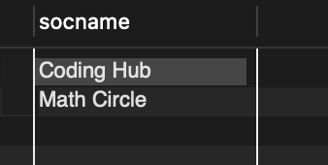

Question19: Display vacant seats for each society.
select s.socname, s.totalseats - count(e.rollno) as vacant_seats from society s
left join enrollment e on s.socid = e.sid
group by s.socid;

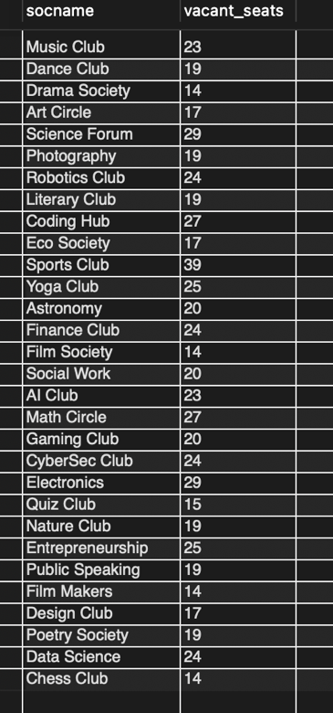
Question20: Increment total seats by 10%.
update society set totalseat = totalseat * 1.10;
select * from society;

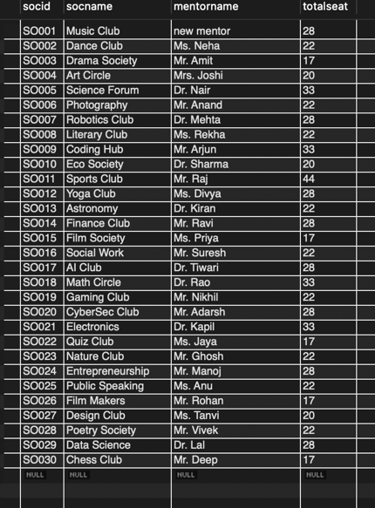

Question21: Add new column FeesPaid (‘Yes’/‘No’) in ENROLLMENT table.
alter table enrollment
add column feepaid enum('yes', 'no') default 'no';
select * from enrollment;

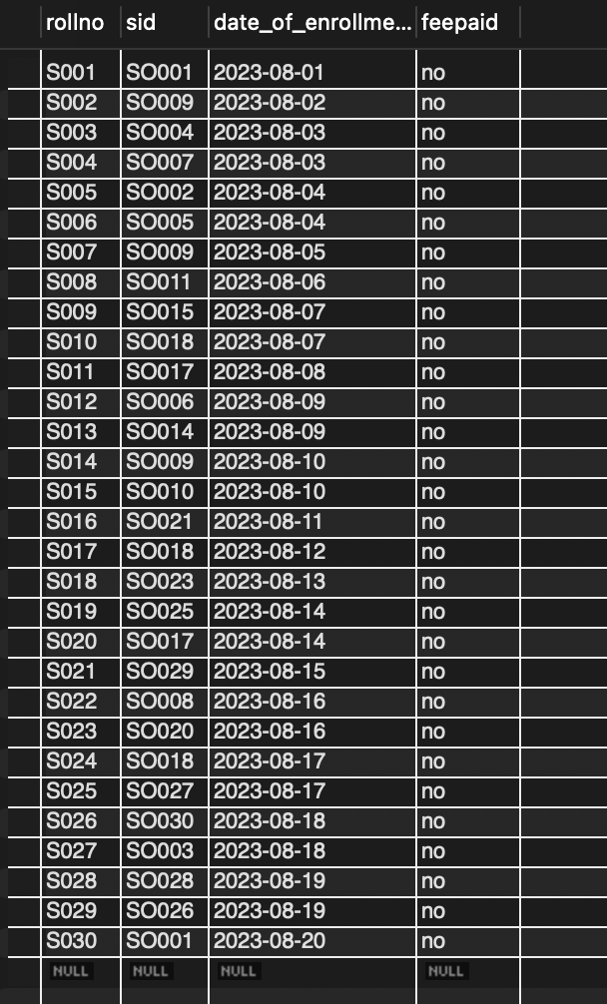

Question22: Update enrollment date for specific societies.
update enrollment
set dateofenrollment = '2018-01-02'
where sid in ('s1', 's2', 's3');

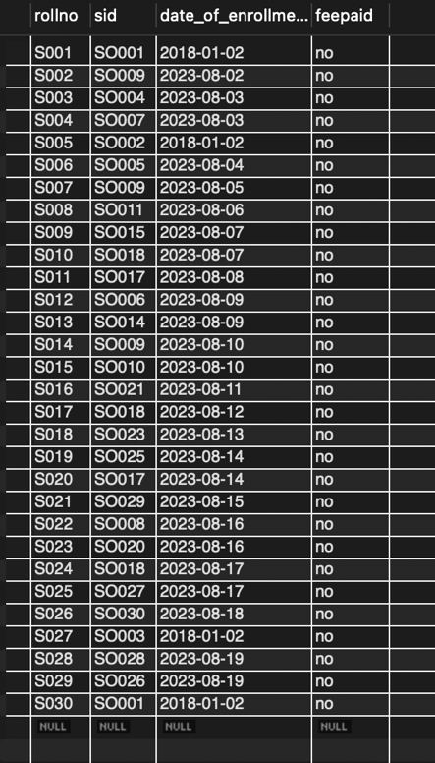
if we use (where sid = 'SO001' or 'SO002' or 'SO003';)
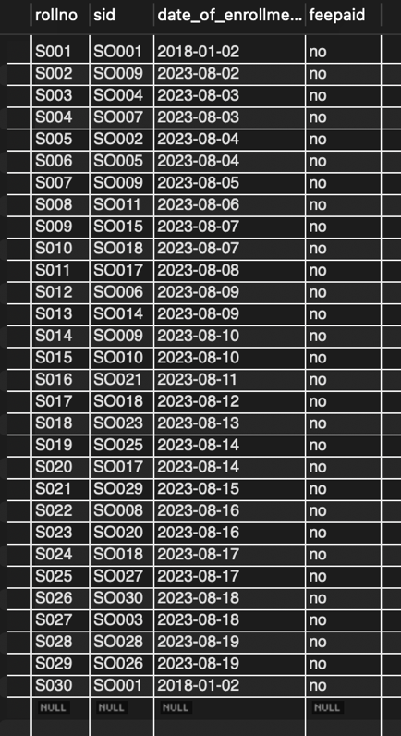
2 row(s) affected, 4 warning(s): 1292 Truncated incorrect DOUBLE value: 'SO002' 1292 Truncated incorrect DOUBLE value: 'SO003' 1292 Truncated incorrect DOUBLE value: 'SO002' 1292 Truncated incorrect DOUBLE value: 'SO003' Rows matched: 2 Changed: 2 Warnings: 4

Question23: Create a view to track society name and total number of students enrolled.
create view society_enrollment_view as
select s.socname, count(e.rollno) as total_enrolled
from society s
left join enrollment e on s.socid = e.sid
group by s.socid;
select * from society_enrollment_view;

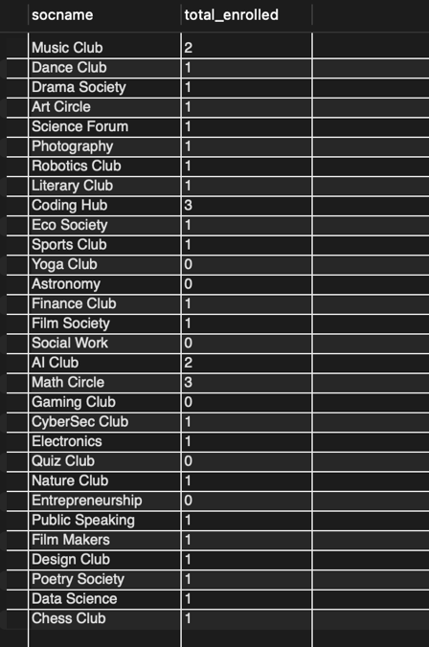

Question24: Find student names enrolled in all societies.
select s.studentname
from student s
join enrollment e on s.rollno = e.rollno
group by s.rollno
having count(distinct e.sid) = (select count(*) from society);

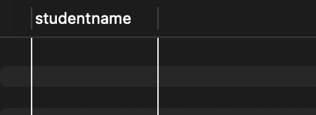

Question25: Count societies with more than 5 students enrolled.
select count(*) as society_count
from (
select sid
from enrollment
group by sid
having count(rollno) > 5
) as t;

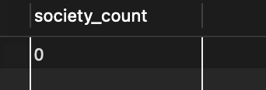

Question26: Add column Mobile number in student table with default value ‘9999999999’
alter table student
add column mobilenumber varchar(15) default '9999999999';
select * from student;

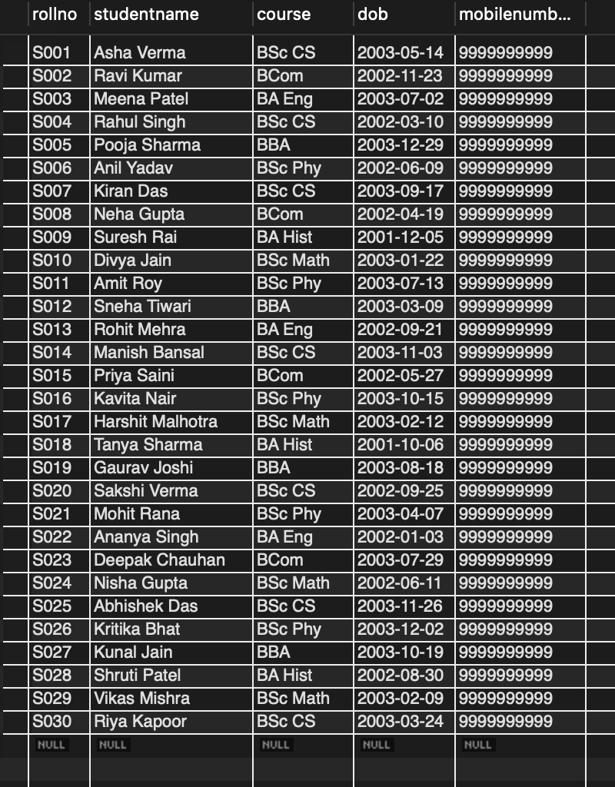

Question27: Find total students older than 20 years.
select count(*) as total_students
from student
where timestampdiff(year, dob, curdate()) > 20;

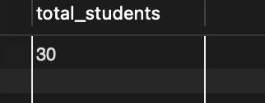

Question28: Students born in 2001 and enrolled in at least one society.
select distinct s.studentname
from student s
join enrollment e on s.rollno = e.rollno
where year(s.dob) = 2001;

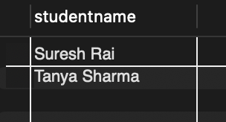

Question29: Count societies starting with ‘S’ and ending with ‘t’ with ≥5 students enrolled.
select count(*) as total_societies
from society s
join enrollment e on s.socid = e.sid
where s.socname like 's%t'
group by s.socid
having count(e.rollno) >= 5;

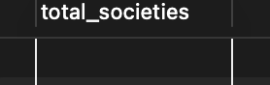

Question30: Display Society name, Mentor name, Total capacity, Total enrolled, and Unfilled seats.
select s.socname, s.mentorname, s.totalseat, count(e.rollno) as total_enrolled, s.totalseat - count(e.rollno) as unfilled_seats
from society s
left join enrollment e on s.socid = e.sid
group by s.socid;

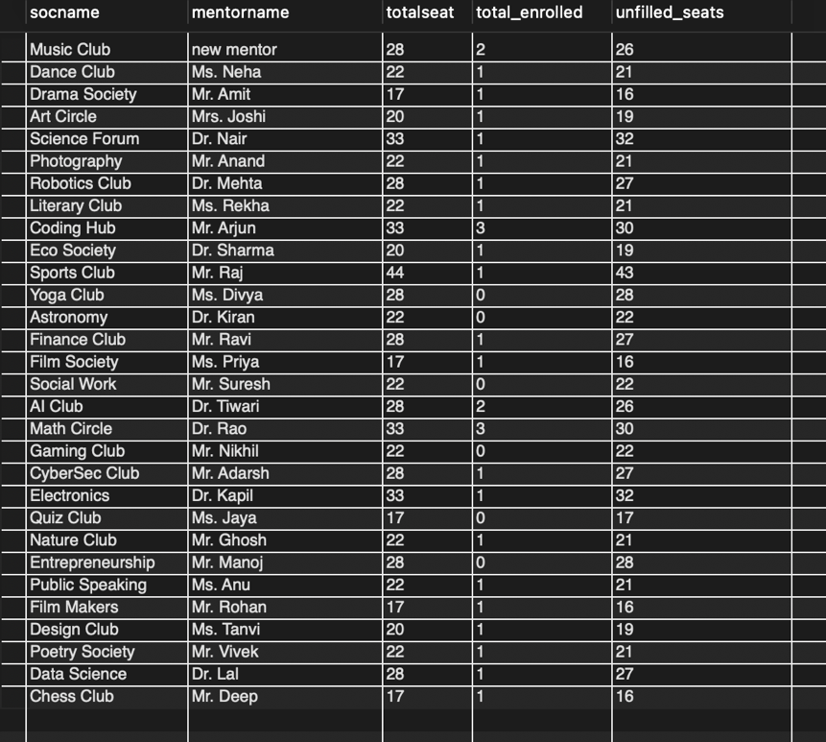

II. Do the following database administration commands:
Create user, create role, grant privileges to a role, revoke privileges from a role, create index

- CREATE USER 'college_user'@'localhost' IDENTIFIED BY 'password123';
- CREATE ROLE 'society_manager';
- GRANT SELECT, INSERT, UPDATE, DELETE ON CollegeDB.* TO 'society_manager';
- GRANT 'society_manager' TO 'college_user';
- REVOKE DELETE ON CollegeDB.* FROM 'society_manager';
- CREATE INDEX idx_studentname ON STUDENT(StudentName);

